John Michael Go
Career Entry Level Java Programming
Date: Jan. 11, 2013

DAY 1

Program Name: Digits

Objective: Input three numbers and system will determine the largest number.

Algorithm:

- User inputs any 3 numbers.
- Program determines the largest of the three numbers entered.

Flowchart:

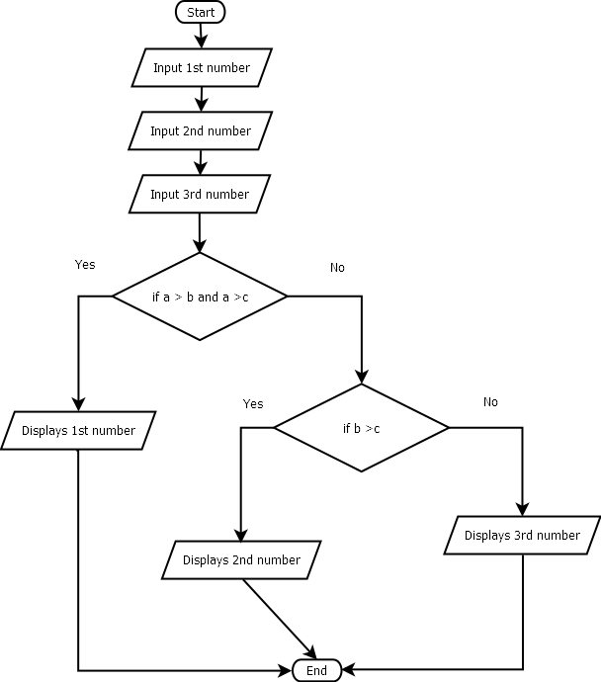
Pseudocode:

import java.util.*;

public class Digits {

public static void main (String[]args){

Scanner console = new Scanner(System.in);
int a, b, c;
// enter 1st number
System.out.println ("");
System.out.print ("Enter 1st number: ");
a = console.nextInt();
System.out.println ("");
// enter 2nd number
System.out.print ("Enter 2nd number: ");
b = console.nextInt();
System.out.println ("");
// enter 3rd number
System.out.print ("Enter 3rd number: ");
c = console.nextInt();
System.out.println ("");
System.out.println ("===============================================================================");
System.out.println ("");
// if a is greater than b and c
if (a>b&&a>c) {
System.out.println ("The largest number of the three digits is " +a);
// if b is greater than c
} else if
(b>c) {
System.out.println ("The largest number of the three digits is " +b);

} else {
System.out.println ("The largest number of the three digits is " +c);

}
System.out.println ("");
System.out.println ("");
System.out.println ("");
}

}

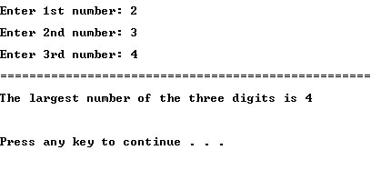
Screenshot:

